*Osmia lignaria* Identification and Development

Helpful resource: <https://idtools.org/exotic_bee/index.cfm?packageID=1185&entityID=9069>

*Osmia lignaria* vs other hymenopterans

The nest *O. lignaria* will be differentiated from other nesting species by their nest plug; *O. lignaria* plugs their nests with mud that is lumpy in appearance and free from other materials. In contrast, *O. californica*, another ephemeral mason bee found in northern Utah, plugs nests with a variety of materials, including mud, masticated leaves, and pollen. Additionally, wasp nests can be easily identified by a smoothed mud plug.

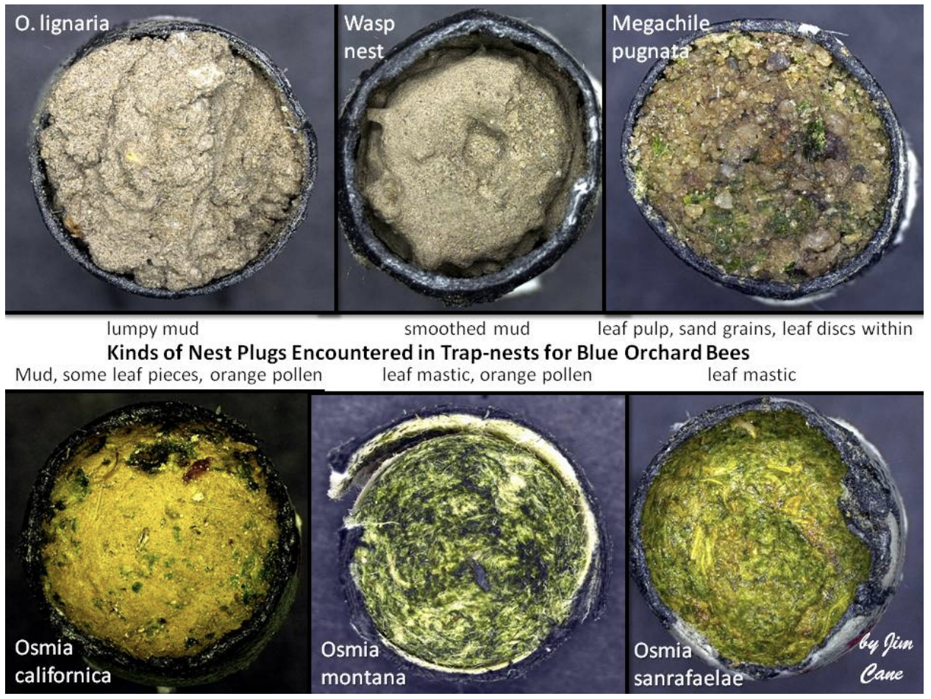

Life stages

* **Egg:** white, shiny, and sausage-shaped
* **1st instar:** encased in the chorion of the egg, recognized by clear poles at the apical and posterior end of the sausage shape
* **2nd instar:** larva starts eating with a pronounced head capsule
* **3rd & 4th instars:** cannot be distinguished
* **5th instar:** indicated by the first sign of frass, usually brown to black, rod-shaped, and slightly flat; development of setae (but this is often hard to see with the way larvae are oriented inside the wells)
* **Cocoon initiation:** first sign of silk spinning by a late fifth instar
* **Cocoon completion:** dark brown color, opaque brown structure with delicate silk outer layer
* **Prepupa:** larva inside of a completed cocoon, marked by cocoon completion
* **Pupa:** segmentation of the body into three segments from the larval form, noted by legs close to the body and opaque wings close to the body
* **Adult:** noted by legs loose from the body and translucent wings away from the body

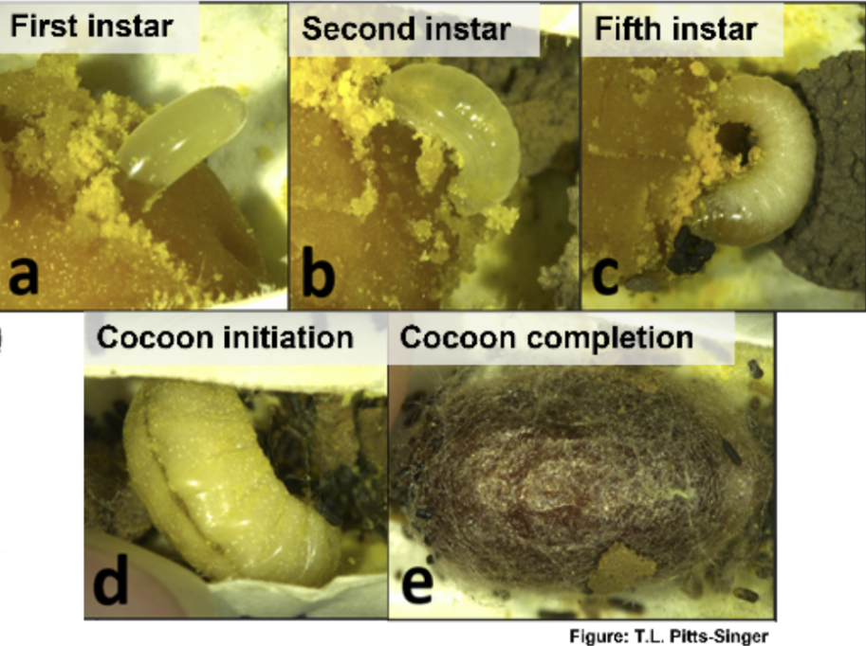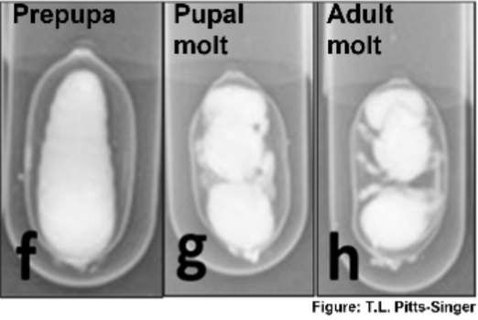

Distinguishing males and females

*Females*

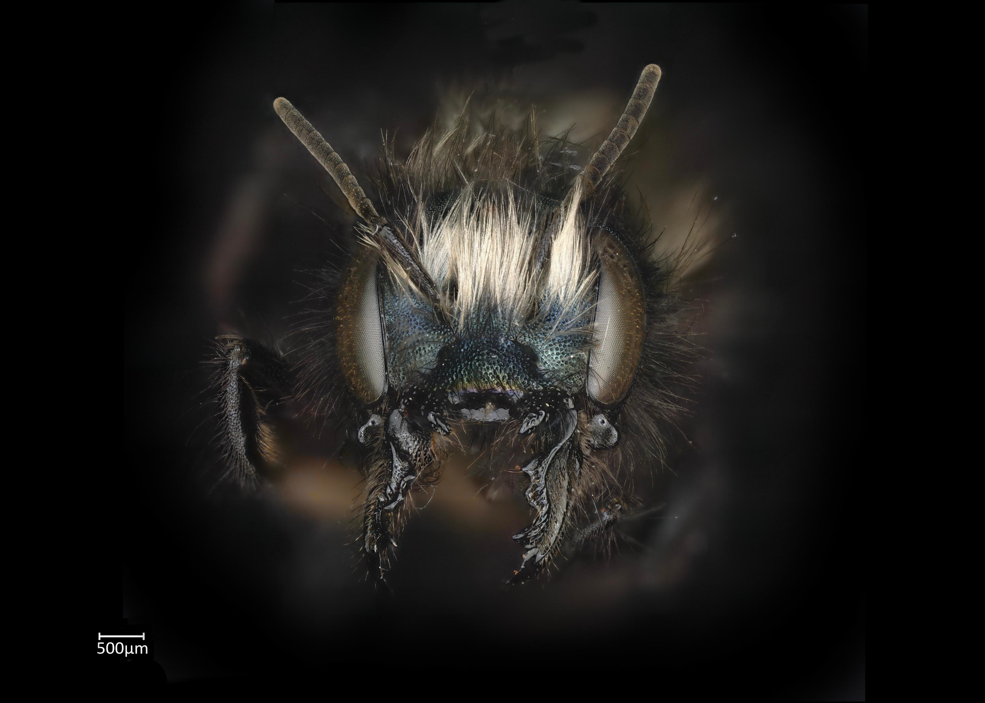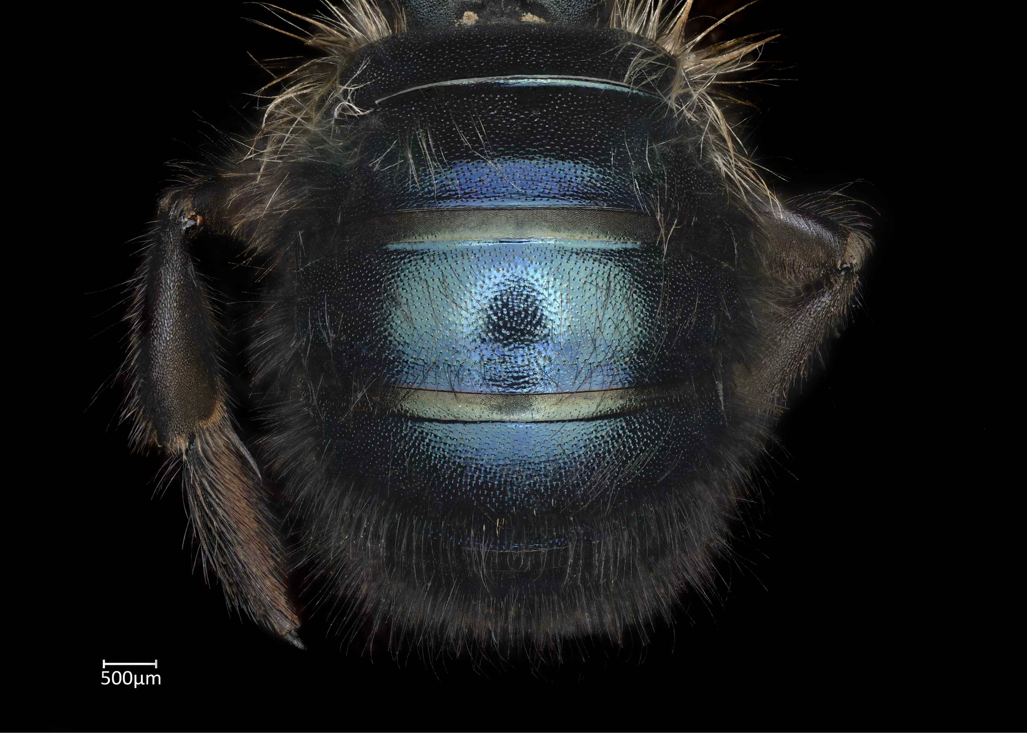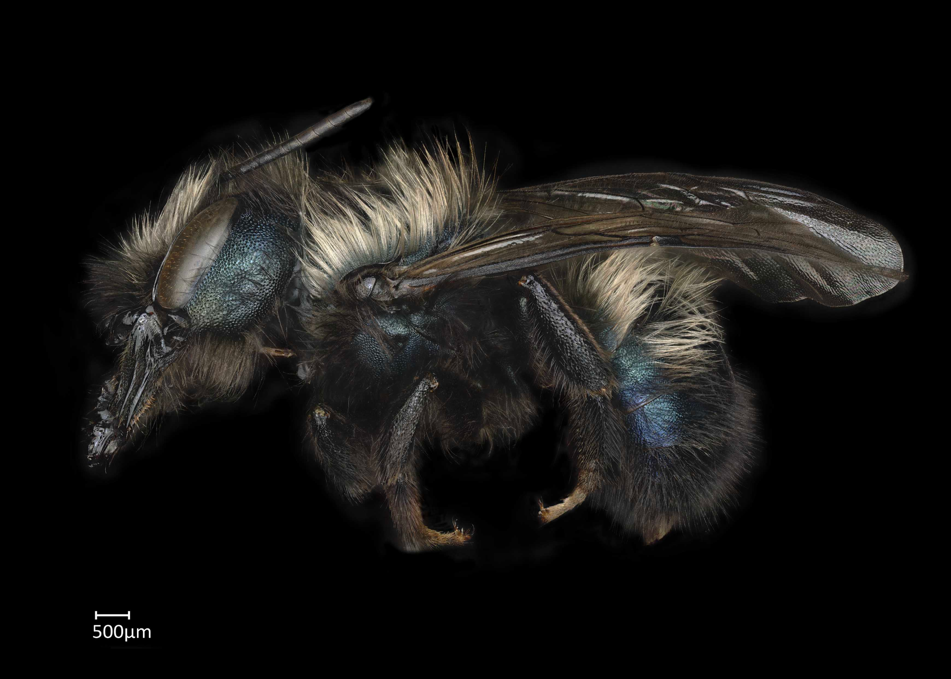

* Females are laid in the last 2-3 brood cells (i.e., these were provisioned first; furthest from the entrance of the nest)
* Females are provided more provision material than males; thus, they are generally larger

*Males*

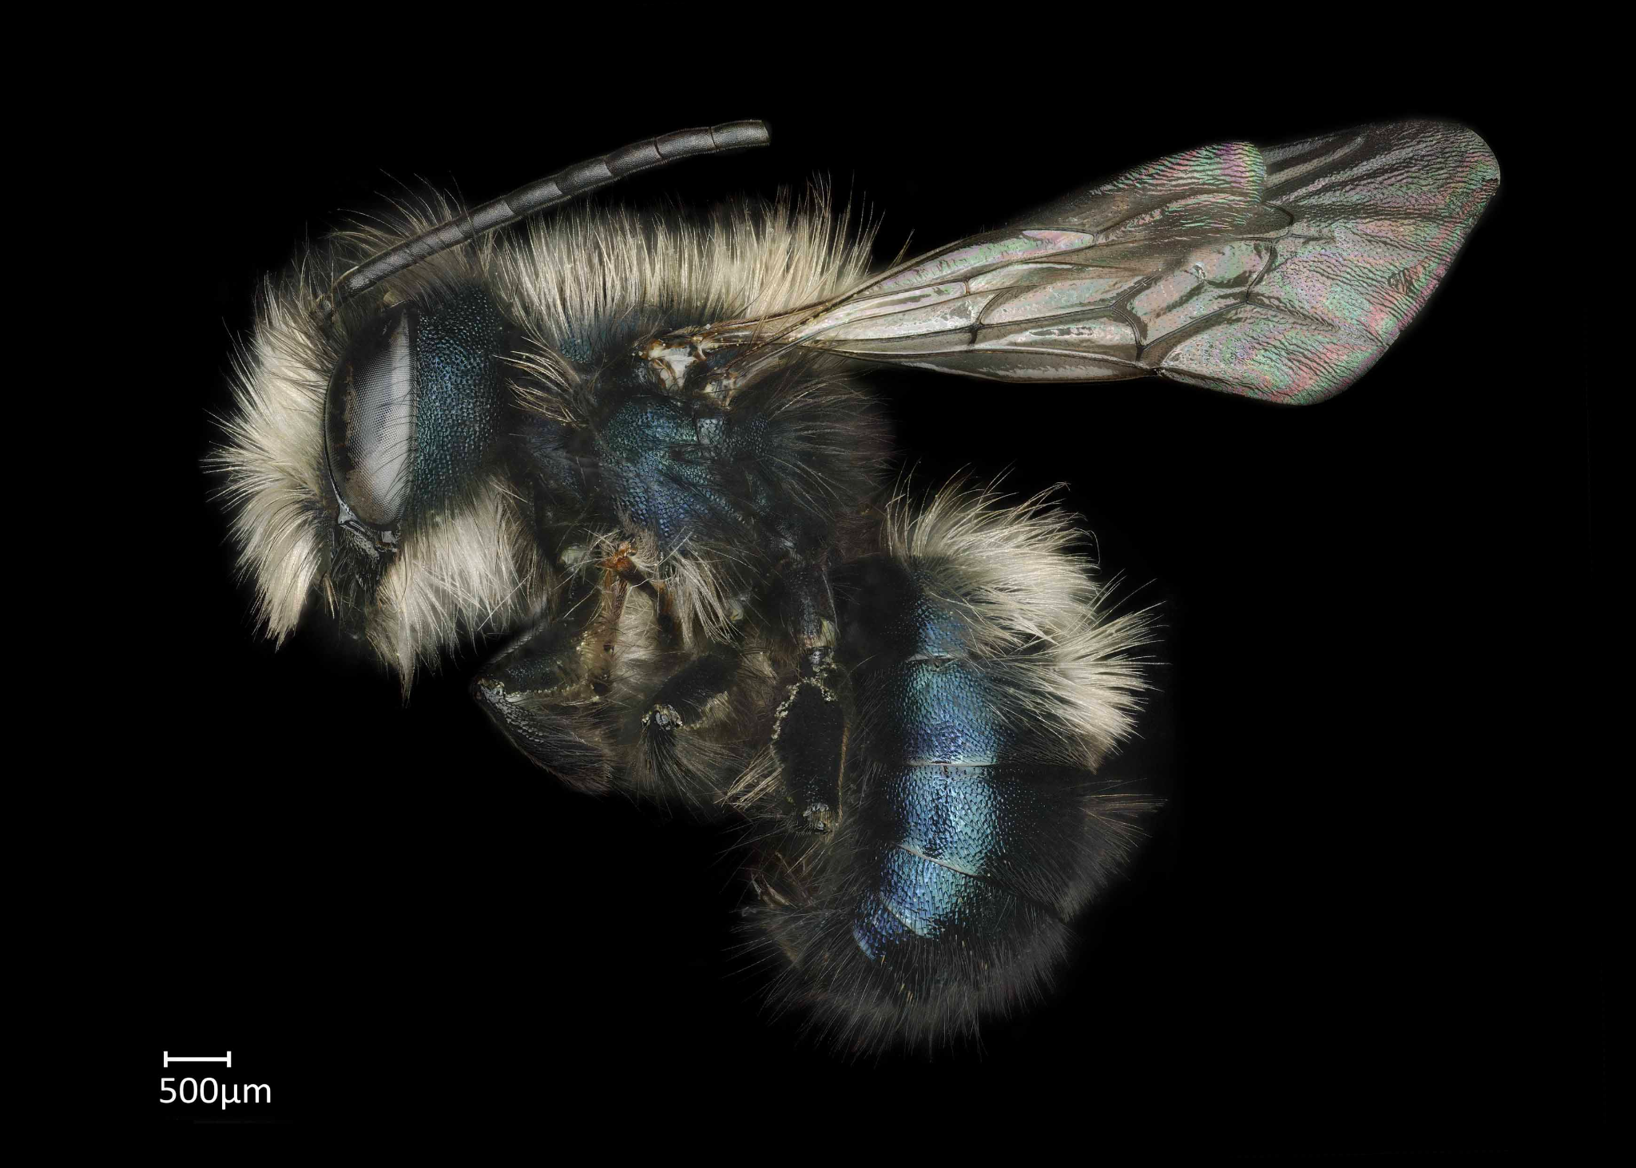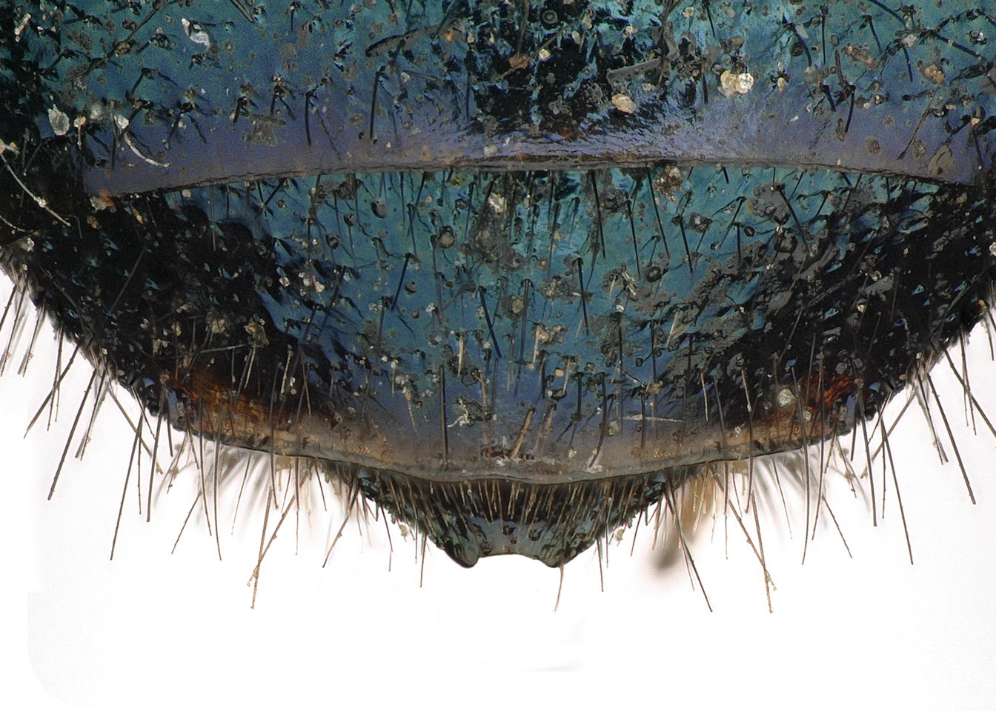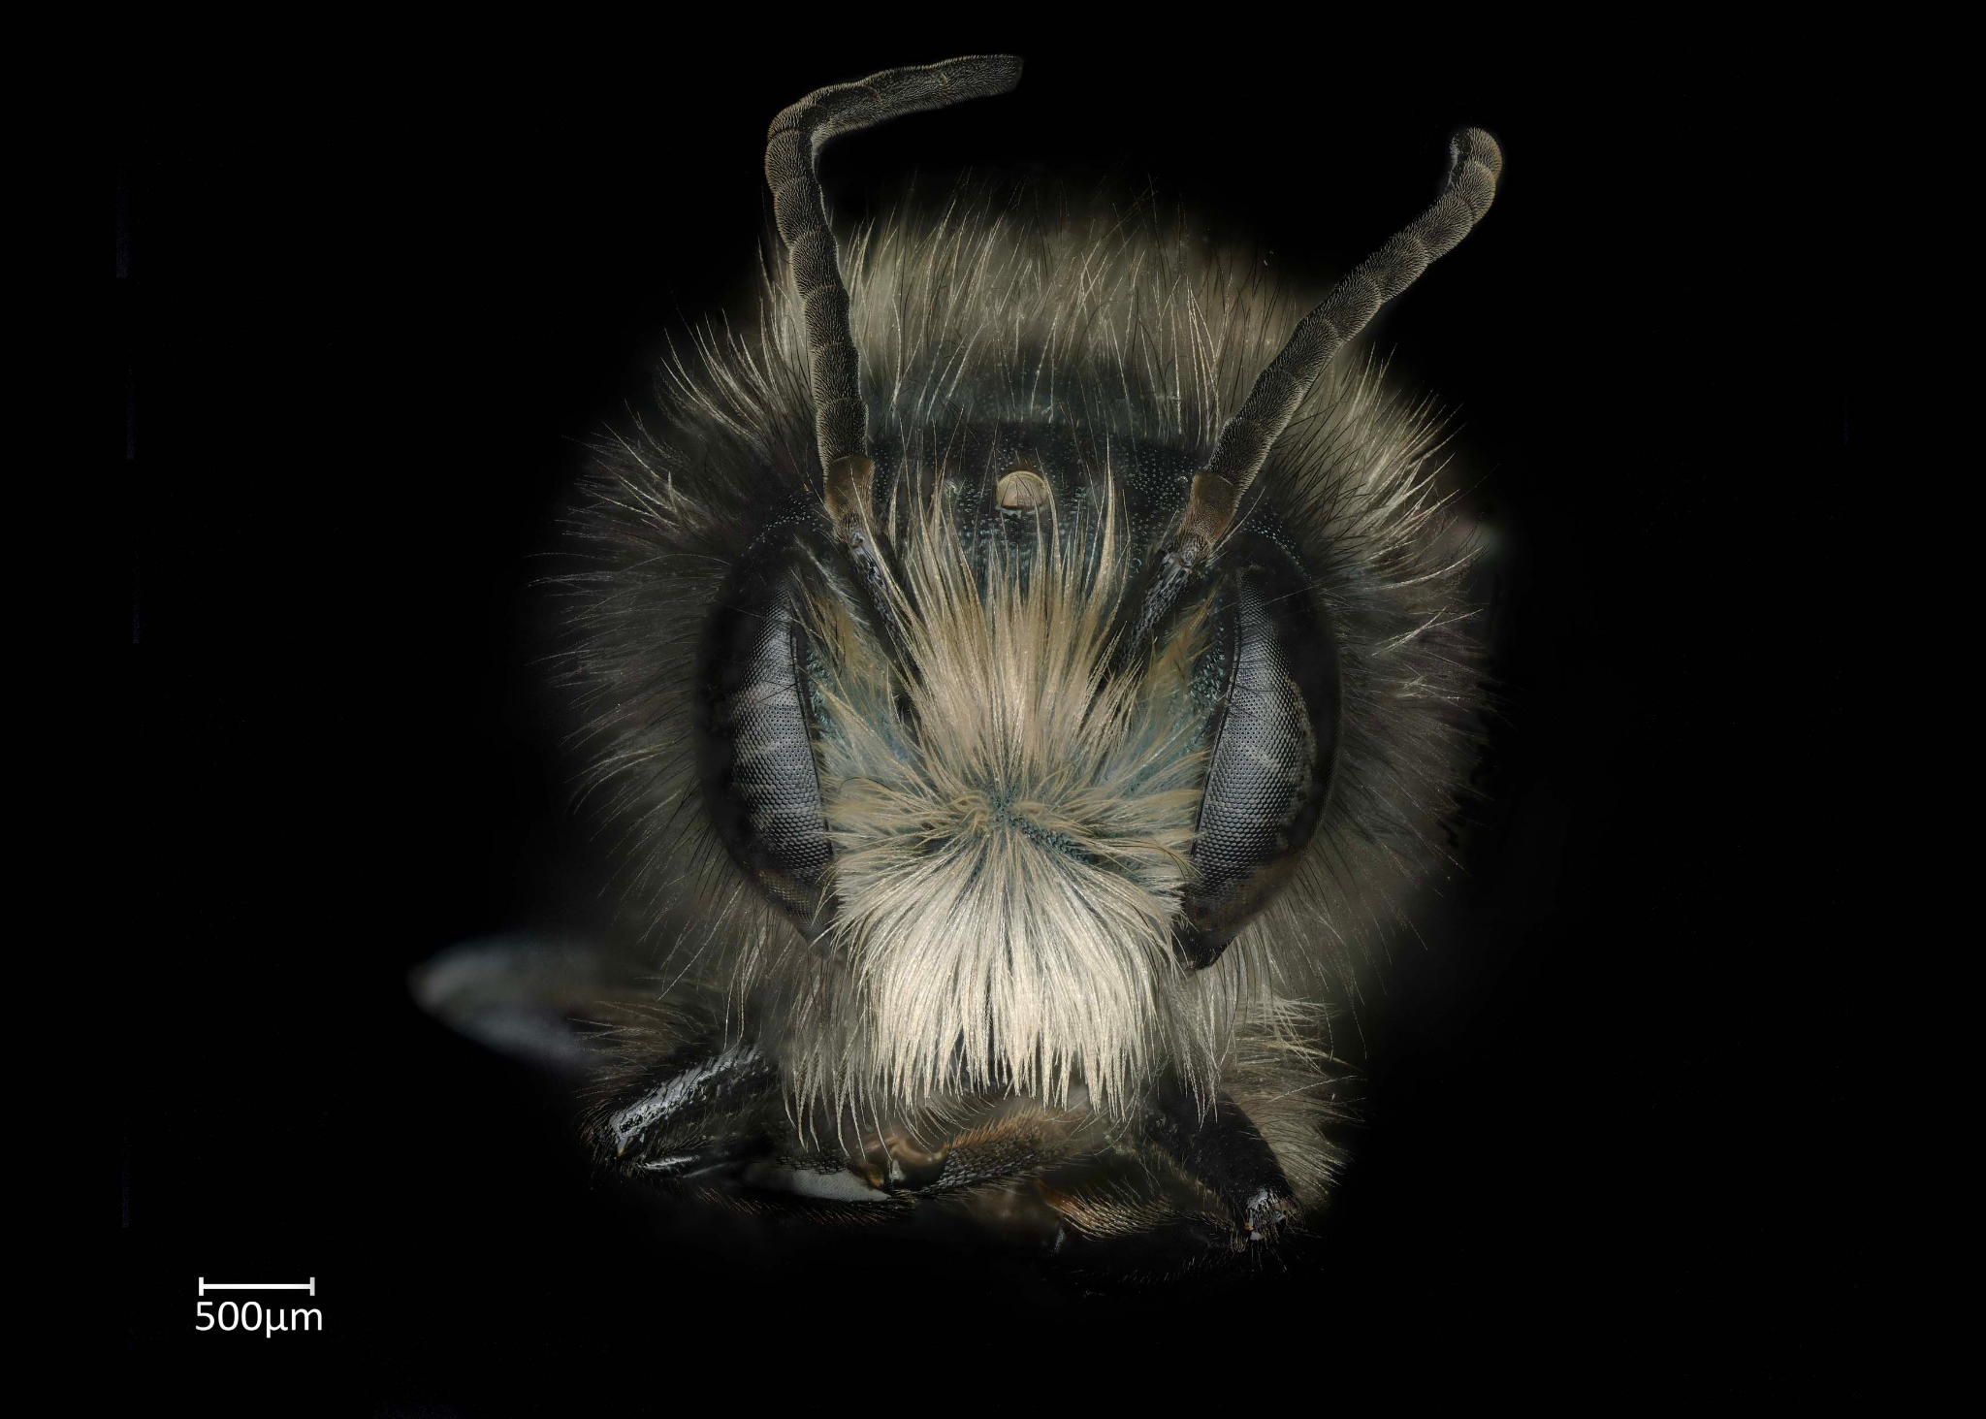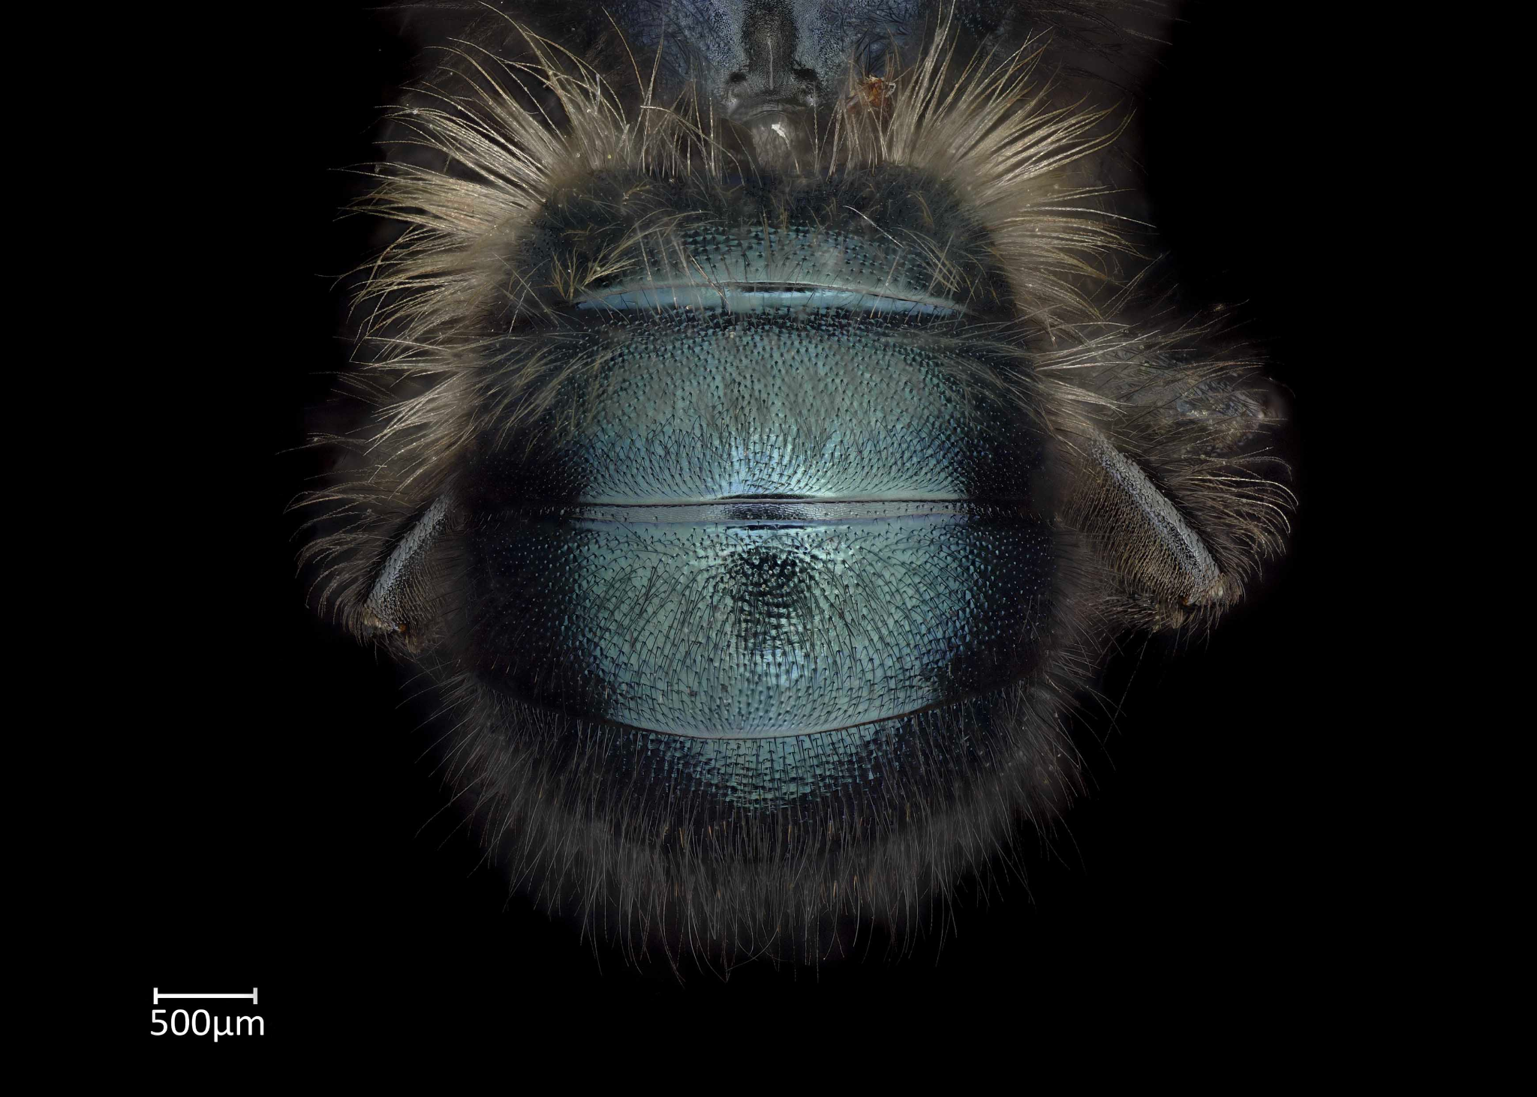

* Males are provided less provision material than females; thus, they are generally smaller